TUESDAY NIGHT
WE CARE GROUP

Tuesday, October 11, 2022
Food at 7:30 Meeting at 8:00 pm
St James White Hall
2532 Burton St SE
Warren OH 44484
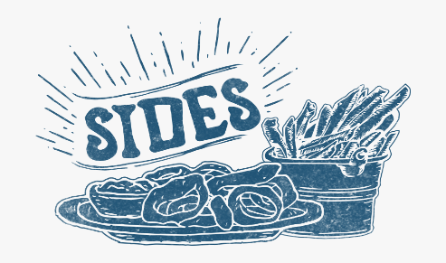
50/50 DOOR PRIZES

COME HELP US CELEBRATE!

